SQL
Session-9
1.Create a SQL script to insert a new order into an Orders table, then use COMMIT to save the transaction and verify that the new order persists after reconnecting to the database.
CREATE DATABASE IF NOT EXISTS ShoppingDB;
CREATE TABLE IF NOT EXISTS Orders (
order_id INT PRIMARY KEY,
customer_name VARCHAR(100),
total_amount DECIMAL(10,2)
) ENGINE = InnoDB;

START TRANSACTION;

INSERT INTO Orders
VALUES (101, 'Neha', 1500.00);

COMMIT;

SELECT * FROM Orders;
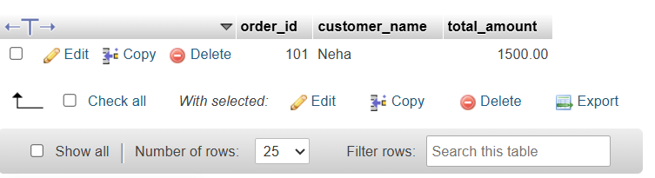

2.Simulate a Zomato-style food order process: insert two new items into an OrderItems table, then use ROLLBACK to undo the changes before committing. Check that no new items remain in the table after rollback.
CREATE TABLE IF NOT EXISTS OrderItems (
item_id INT PRIMARY KEY,
item_name VARCHAR(100),
quantity INT,
price DECIMAL(10,2)
) ENGINE = InnoDB;

START TRANSACTION;

INSERT INTO OrderItems
VALUES (1, 'Pizza', 1, 299.00);

INSERT INTO OrderItems
VALUES (2, 'Burger', 2, 199.00);

ROLLBACK;

SELECT * FROM OrderItems;
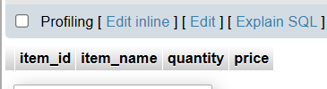

3.In a Flipkart-like shopping cart scenario, use SAVEPOINT to mark a point after adding a product to the Cart table, add another product, then use ROLLBACK TO SAVEPOINT to undo only the last addition. Show the final contents of the Cart table.
CREATE TABLE IF NOT EXISTS Cart (
cart_id INT PRIMARY KEY,
product_name VARCHAR(100),
price DECIMAL(10,2)
) ENGINE = InnoDB;

START TRANSACTION;

INSERT INTO Cart
VALUES (1, 'Headphones', 999.00);

SAVEPOINT product_added;

INSERT INTO Cart
VALUES (2, 'Keyboard', 1499.00);

ROLLBACK TO SAVEPOINT product_added;

COMMIT;

SELECT * FROM Cart;
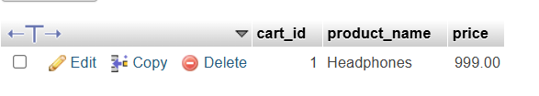

4.Write a trigger on a Wallet table that automatically deducts the purchase amount from the user's balance whenever a new transaction is inserted, similar to how Paytm updates wallet balance after a payment.
CREATE TABLE IF NOT EXISTS Wallet (
user_id INT PRIMARY KEY,
user_name VARCHAR(100),
balance DECIMAL(10,2)
) ENGINE = InnoDB;

CREATE TABLE IF NOT EXISTS WalletTransactions (
transaction_id INT PRIMARY KEY,
user_id INT,
amount DECIMAL(10,2),
description VARCHAR(100)
) ENGINE = InnoDB;

INSERT INTO Wallet VALUES (1, 'Neha', 5000.00);

DELIMITER //

CREATE TRIGGER deduct_wallet_balance
AFTER INSERT ON WalletTransactions
FOR EACH ROW
BEGIN
UPDATE Wallet
SET balance = balance - NEW.amount
WHERE user_id = NEW.user_id;
END //

DELIMITER ;

INSERT INTO WalletTransactions
VALUES (101, 1, 500.00, 'Shopping Payment');

SELECT * FROM Wallet;
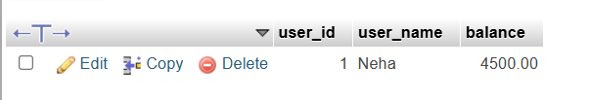

5.Use ChatGPT to generate a SQL test scenario where a trigger incorrectly updates a user's balance after an expense entry. Paste the scenario and your corrected trigger code, explaining how you fixed the error.Ask ChatGPT for a buggy trigger example and a test case that exposes the bug.
CREATE TABLE Wallet (
user_id INT PRIMARY KEY,
user_name VARCHAR(100),
balance DECIMAL(10,2)
);

CREATE TABLE WalletTransactions (
transaction_id INT PRIMARY KEY,
user_id INT,
amount DECIMAL(10,2),
description VARCHAR(100)
);
INSERT INTO Wallet VALUES
(1, 'Neha', 5000.00),
(2, 'Neha', 5000.00);
DELIMITER //

CREATE TRIGGER deduct_wallet_balance
AFTER INSERT ON WalletTransactions
FOR EACH ROW
BEGIN
UPDATE Wallet
SET balance = balance - NEW.amount
WHERE user_id = NEW.user_id;
END //

DELIMITER ;
INSERT INTO WalletTransactions VALUES
(101, 1, 500.00, 'Shopping Payment'),
(102, 1, 500.00, 'Shopping Payment'),
(103, 1, 500.00, 'Shopping Payment');
SELECT * FROM Wallet;
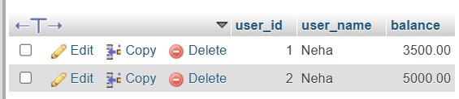
- Initial balance = ₹5,000
- Total transactions = 3
- Each transaction = ₹500
- Total deduction = ₹1,500
- Final balance = ₹5,000 − ₹1,500 = ₹3,500
The trigger automatically deducts the transaction amount from the user's wallet balance whenever a new transaction is inserted.

